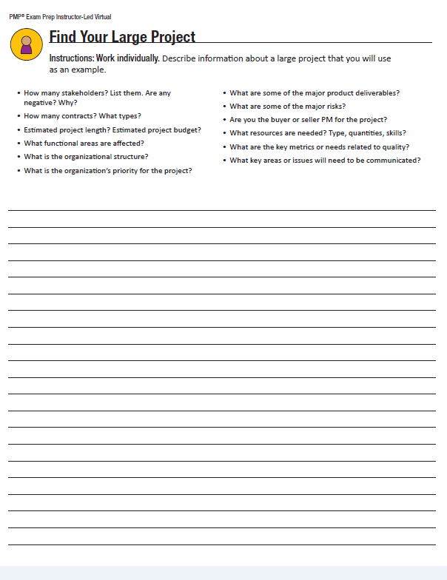

**2**

**Stakeholder Requirements:** Operational library/internet facility for public use

Additional paperwork to be developed: architectural drawings of facility, library management software specifications and specifications of internet library café design from Sweden

**Key Project Deliverables:**

* Schedule and WBS
* Stakeholder Repository and Register
* Analysis of library behaviour and customer service expectations
* Analysis of risks to operation
* Focus Groups and Surveys

**Key Product Deliverables:**

* New building with ample parking and easy access
* Lending library stocked with children’s books with wide array of topics for all youth
* Select magazines and senior citizen reading material
* Large reading lounge circled by privacy booths with advanced connectivity for internet engagement
* Central librarian area, kitchen and break room and auxiliary meeting room

**Assumptions:**

* Land is licensed for public use and ready for building
* Library management software is sufficient for lending library
* Pre-fab privacy carols can be reasonably shipped from Sweden
* Cost of computers will not exceed existing budget
* Swedish consultant will have enough time to commit to the project
* Construction on the external facility will begin right away and be completed within 8 months to allow for completion of inside

**Constraints:**

* Stakeholder Register due in one week – focus groups to begin in three weeks, town hall meetings in a month
* Initial procurement list due to Finance Department in two weeks
* Scope is to remain a limited service facility
* WBS due in two weeks – activity lists due in three weeks
* Risk register due in two weeks

**Measurable Project Objectives:**

* Facility is completed by January 31, 2020
* Community usage of facility exceeds usage of previous facility by 30%
* Customer satisfaction above 75%

**Project Approval Requirements**

* The sponsor will approve the budget, the construction company contract and architectural plan, the major risks, the WBS and the project plan before work begins.